**#FunTimesWithTheTA   
PulseFit – a “Do-It-Yourself” Heartbeat Sensor with Auto-Adjusting Threshold**

Adapted from: <http://www.instructables.com/id/Heart-Sensor-With-AutoAdjusted-Threshold-and-Heart/> by Orlando S. Hoilett

**Introduction**

In this installment of #FunTimesWithTheTA we will build PulseFit a “Do-It-Yourself” Heartbeat Sensor with Auto-Adjusting Threshold. With PulseFit, we will be able to collect a photoplethysmogram from a person’s finger, plot the waveform, and calculate heart rate. Additionally, we are going to add a simple circuit that automatically detects when the systolic phase is occurring and will blink an LED in response.

**Objectives**

1. Recall that photodiodes output a current in response to incident light
2. Summarize the various phases of the cardiac cycle as depicted in a photoplethysmograph (Figure 1)
3. Explain the application of time constants as it relates to the diode-capacitor peak detector
4. Create a circuit to detect heart beats using light-emitting diodes and photodiodes
5. ***Have some FUN! FUN! FUN!***

Photoplethysmography is the study of the change of volume in an organ using light. Photoplethysmography has famously been applied to measuring the volume of blood in someone’s finger (or other periphery such as a toe or earlobe) as a method of calculating heart rate. In this technique, the finger is illuminated by a light-emitting diode (LED) (often red, IR, or green) and a photodetector measures the amount of light that passes through the finger. The intensity of light that passes through the finger varies with varying blood volume in the finger, which corresponds to different phases of the cardiac cycle. The pulse waveform has a very characteristic waveform (Figure 1). It has a fast rise, which corresponds to the systolic phase (ventricles pumping blood to the rest of the body) and a slow drop-off (diastole). Additionally, upon examination of the photoplethysmography, we often notice a secondary peak occurring soon after the first. This secondary peak is called the dicrotic notch and is associated with a secondary pressure wave that is sent through the blood vessels due to the closure of the aortic valve. From studying the pulse waveform, we can calculate heart rate as well as determine other biometric quantities such as: heart rate variability or relative cardiac output.

There are two major types of photoplethysmography that are used in the real-world. These two types are transmission photoplethysmography and reflectance photoplethysmography. In the transmission case, we are detecting the amount of light that passes through a person’s finger. In the reflectance case, we are detecting the amount of light that reflects from the finger. Reflectance photoplethysmography is famously employed by smartwatches and other fitness trackers, while transmission photoplethysmography is used in the clinic and is probably the most utilized of the two techniques. You may be familiar with the [finger pulse oximeter](https://www.google.com/search?q=finger+pulse+oximeter&num=30&newwindow=1&source=lnms&tbm=isch&sa=X&ved=0ahUKEwiArbL8p8jWAhXhxlQKHaI8BHAQ_AUICygC&biw=1280&bih=652) used by nurses in a clinical setting to collect heart rate and blood oxygen data from a patient. We will be using reflectance-mode finger photoplethysmography for this lesson.

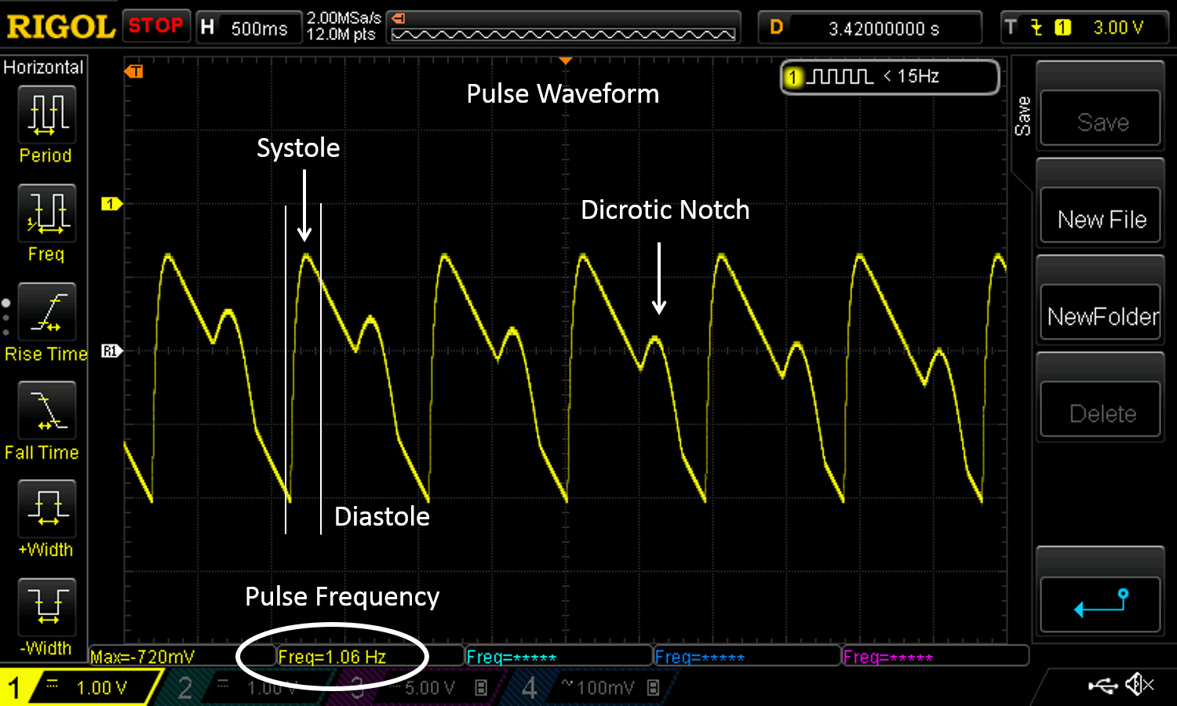

*Figure 1: Example output of PulseFit highlighting the cardiac phases. (Ignore the exact output voltages as this graph was obtained from a different circuit)*

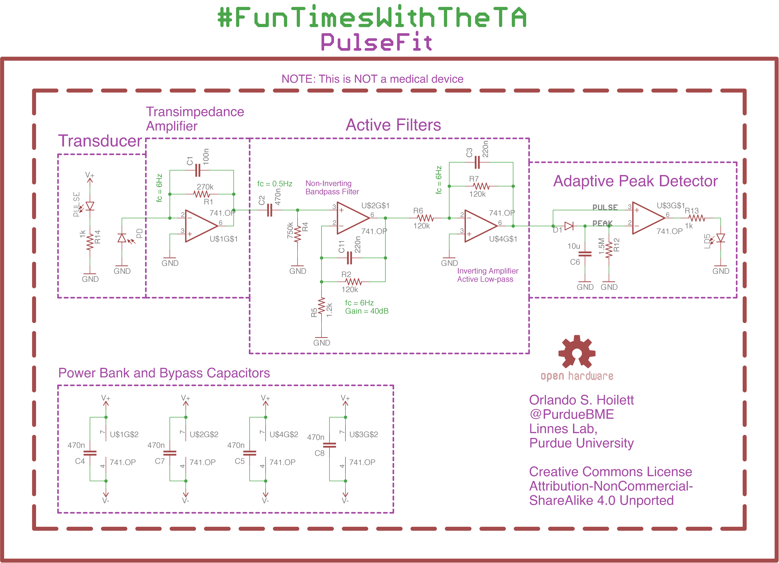

*Figure 2: Circuit diagram of PulseFit.*

**ABET Outcomes**

“an ability to function effectively on a team whose members together provide leadership, create a collaborative and inclusive environment, establish goals, plan tasks, and meet objectives” (Outcome 5)

“an ability to develop and conduct appropriate experimentation, analyze and interpret data, and use engineering judgment to draw conclusions” (Outcome 6)

“an ability to acquire and apply new knowledge as needed, using appropriate learning strategies.” (Outcome 7)

http://www.abet.org/accreditation/accreditation-criteria/criteria-for-accrediting-

engineering-programs-2018-2019/

**Link to Circuit Lab Simulation**

https://www.circuitlab.com/circuit/95bc33958278/pulsefit/

**Table of Contents**

|  |  |
| --- | --- |
| **Section** | **Page** |
| Introduction | **1** |
| Objectives | **1** |
| #PulseFit Schematic | **2** |
| ABET Outcomes | **3** |
| Link to CircuitLab Simulation | **3** |
| Key Terms and Definitions | **5** |
| Part #1: Transducer: The Light-Emitting Diode and the Photodiode | **7** |
| Part #2: Transimpedance Amplifier (TIA) | **9** |
| Part #3: Active Filters (Active Bandpass Filter and Active Low-Pass Filter) | **11** |
| Part #4: Adaptive Peak Detector, Comparator, and Output Indicator | **13** |
| Part #5: Heart-shaped LED Indicator | **16** |
| Revision History | **17** |

**Key Terms and Definitions**

***DC Signals***

A voltage signal that does not vary with time

***AC signals***

A voltage signal that varies with time

***Noise***

Any unwanted signal (generally interfering with the signal you’re trying to measure)

***Bypass Capacitors***

Capacitors that are connected to voltage sources for the purpose of removing noise

***Buffer amplifier***

An op amp being used to isolate one portion of the circuit from another (as the op-amp draws no current)

***Operational Amplifier or Op Amp***

A type of circuit component that can perform mathematical operations on electrical signals such as multiplication, division, logarithm, etc.

***Cut-off frequency***

The frequency at which a filter begins to attenuate signals. Typically defined as the frequency at which the output of the filter is 70.7% of the input signal.

***Attenuation***

A decrease in signal amplitude.

***Gain***

An increase in signal amplitude.

***High-pass Filter***

A type of filter that causes signals with a higher frequency than the specified cut-off frequency to pass with minimal to no attenuation or change in amplitude, but that attenuates signals with frequencies lower than the cut-off frequency.

***Low-pass Filter***

A type of filter that causes signals with a lower frequency than the specified cut-off frequency to pass with minimal to no attenuation or change in amplitude, but that attenuates signals with frequencies higher than the cut-off frequency.

***Band-pass Filter***

A type of filter than causes signals lower than a given frequency and higher than a given frequency to become attenuated while only passing signals within a given “band” of frequencies. A bandpass filter is a simple combination of a low and a high-pass filter.

***Passband***

The passband refers to the range of frequencies that are not attenuated by a given filter

***Stopband***

The stop band refers to the range of frequencies that are completely attenuated by a given filter.

**Part #1: Transducer: The Light-Emitting Diode and the Photodiode**

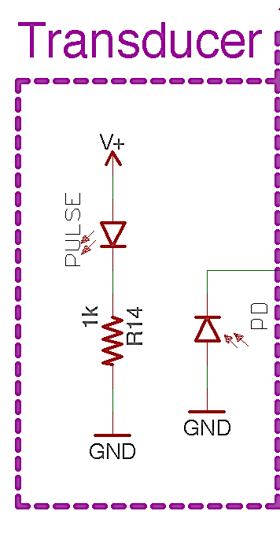

*Figure 3: LED and Photodiode.*

***Red Light-Emitting Diode (LED)***

LEDs are light-emitting diodes. These are special class of diodes that light up when powered. For detecting heartbeats, really any color LED can be used, but red, IR (infrared), and green are most common. Red and IR LEDs are often employed in pulse oximeters for measuring blood oxygen. Green LEDs are heavily used by smartwatches and fitness trackers as green has been reported to pass through thicker tissue, like the wrist, better than red and IR light.

As mentioned earlier, LEDs are diodes, so the polarity of the LED is important. The anode is the positive side of the LED, while the cathode is the negative side. For ease of use, the anode usually has a longer pin than the cathode.

***Photodiode***

Photodiodes are handy circuit components that convert light energy into electrical current. Photodiodes allow us to measure the amount of light that reflects off the finger and convert the light energy into current.

Photodiodes come in many varieties. The photodiode we will be using is the BPV10, a standard PIN diode with decent light sensitivity and responsivity. The BPV10 is sensitive to the entire visible spectrum, so we must be careful to prevent excessive ambient light from affecting our measurements. The rest of our circuit has been designed to filter out changes in the signal due to ambient light, but please be aware that we may need to do a few more modifications nonetheless.

We will be placing the LED and photodiode snuggly in a perfboard. Finger photoplethysmography is very sensitive to movement noise. Placing the LED and photodiode in a fixed platform will help remove movement noise.

***Instructions***

1. Place the LED and photodiode into the perfboard. They should be able to fit side-by-side.
2. Solder the two components onto the perfboard
3. Cut the perfboard to size to remove empty space.

***Testing:***

1. Power the LED with +12 V. It should light up.

**NOTE:** LED brightness increases with increasing current. Please limit the current through the LED to about 10mA.

**Part #2: Transimpedance Amplifier (TIA)**

**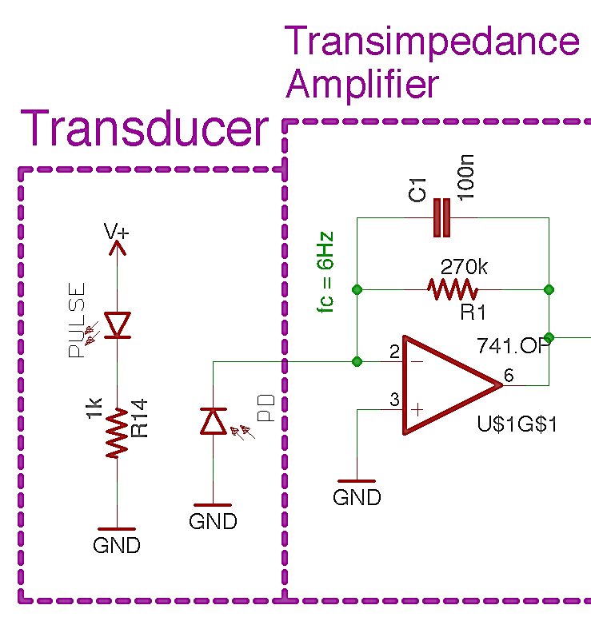***Figure 4: Transimpedance Amplifier (TIA) or “current-to-voltage” converter. The photodiode is in a zero-bias state. When light hits the photodiode, it produces a current that is converted to a voltage using the TIA. The output voltage of the TIA should be positive, increasing from zero with increasing LED light intensity.*

A transimpedance amplifier (TIA) is a “current-to-voltage” converter that converts the current produced by the photodiode, to a voltage that can be read at the output of the amplifier. This occurs because of Kirchhoff’s Current Law. The current produced by the photodiode flows away from the inverting pin of the op amp to ground. KCL says that whatever current flows out of the node, must also flow into the node. As such, we get an equal and opposite current through RF and CF. Ohm’s Law says that V = I*ZF (where ZF is the equivalent impedance of RF and CF), which results in a voltage at the output of the amplifier that is proportional to the photocurrent.

Additionally, CF and RF create a low-pass filter with a cut-off frequency defined by

$f_{c}=1/{2πR_{F}C_{F}}$ (2)

RF for a transimpedance circuit is typically very large, which means that our TIA has a very high gain. High gain in an amplifier can often cause unstable behavior known as “oscillations”. CF helps dampen high frequency oscillations by creating a low-pass filter with RF. In the case of our TIA, CF also helps filter 60 Hz noise. We will set the “cut-off” frequency of our low-pass filter to about 6Hz. The frequency of our pulse waveform should never exceed 3Hz (180 BPM), so 6Hz is more than sufficient for filtering out high frequency noise without attenuating frequencies of our pulse waveform (1-3Hz), very much.

Additionally, the gain of our TIA is defined by the following equation (if we ignore the effect of CF inside of our passband), where IP is the photodiode photocurrent and RF is the feedback resistance:

$V_{out}=-I_{P}*R_{F}$ (3)

Using equation 3, we can easily calculate the output voltage of our amplifier given a certain photocurrent and feedback resistance.

***Testing:***

1. Power the TIA with +/- 12 V from the benchtop power supply
2. Use your oscilloscope to view the output of the TIA.
3. Repeatedly block and un-block the photodiode, preventing the red light from hitting the photodiode, by placing an opaque object between the two components. You should see a changing output similar to a square wave. The difference may only be a few tens of milliVolts.

***Try It!***

1. Place your finger on the photodiode and LED.
2. Adjust the gain of the TIA amplifier so that its output is between 6-8 Volts.

You should be able to see some AC signal due to your pulse, at this stage. Try changing the channel of your oscilloscope to AC coupling so you can adjust the voltage divisions to a smaller scale. Can yo use your pulse?

**NOTE:** For adjusting the gain at this stage, I would recommend increasing or decreasing the brightness of the LED first, before changing the gain of the TIA. If you do adjust the feedback resistor of the TIA amplifier, please remember to adjust the capacitor value as well. I would recommend keeping a cutoff frequency of around 5-10Hz.

**Part #3: Active Filters (Active Bandpass Filter and Active Low-Pass Filter)**

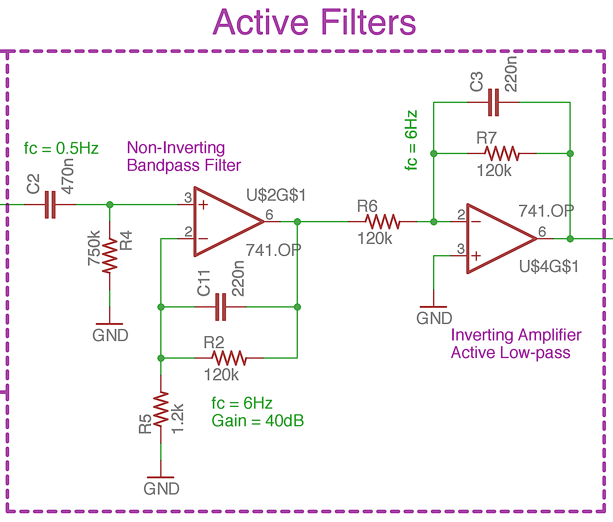

*Figure 5: Two active filters, an active bandpass filter and an active low-pass filter to provide gain and decrease noise.*

A band-pass filter is a useful filter configuration that allows us to combine the effects of low-pass and high-pass filters resulting in only a “band” of frequencies in the passband. We will use a bandpass filter to block DC signals to ensure that only the AC portion of our signal is being amplified and for filtering high frequency noise such as 60 Hz. The band-pass filter has two cut-off frequencies set by the low-pass and high-pass filter. Recall from equation 1 that the cut-off frequency of low-pass and high-pass filters are determined by

$f_{c}=1/{2πR_{F}C_{F}}$ (2)

The low-pass filter determines the higher cut-off frequency. The high-pass filter determines the lower cut-off frequency.

Notice the difference in the configurations of the active filters. The first filter is an active bandpass filter in a non-inverting configuration, while the other is an active low-pass filter in an inverting configuration. This is done simply to invert our signal so that we have a positive increase in voltage during the systolic phase and is done mostly for convenience sake. The gain of our bandpass filter circuit should be about 40dB, while the gain of the active low pass filter should be 0dB. However, we will probably adjust the gains of these amplifiers as bit.

***Testing***

1. Power the op amps with +/- 12 V from the benchtop power supply
2. Create a 1 Hz, 20 mVpp sine wave from your function generator.
3. Input the sine wave into your bandpass filter.
4. You should have an output signal of about 2 Vpp.

***Try It!***

1. Try changing the frequency of your input sine wave to 60Hz.
2. Also change the signal amplitude 10Vpp
3. You should have an output signal of about 100mVpp.

**NOTE:** If you adjust the gain of the bandpass filter, you should change R5 if you can, but do not decrease it to lower than 680Ohms. If you need to change R2, make sure you adjust C11 to ensure the cutoff frequency of the filter is between 5-10Hz. If you adjust the gain of the inverting amplifier, do so by changing R6 alone.

**Part #4: Adaptive Peak Detector, Comparator, and Output Indicator**

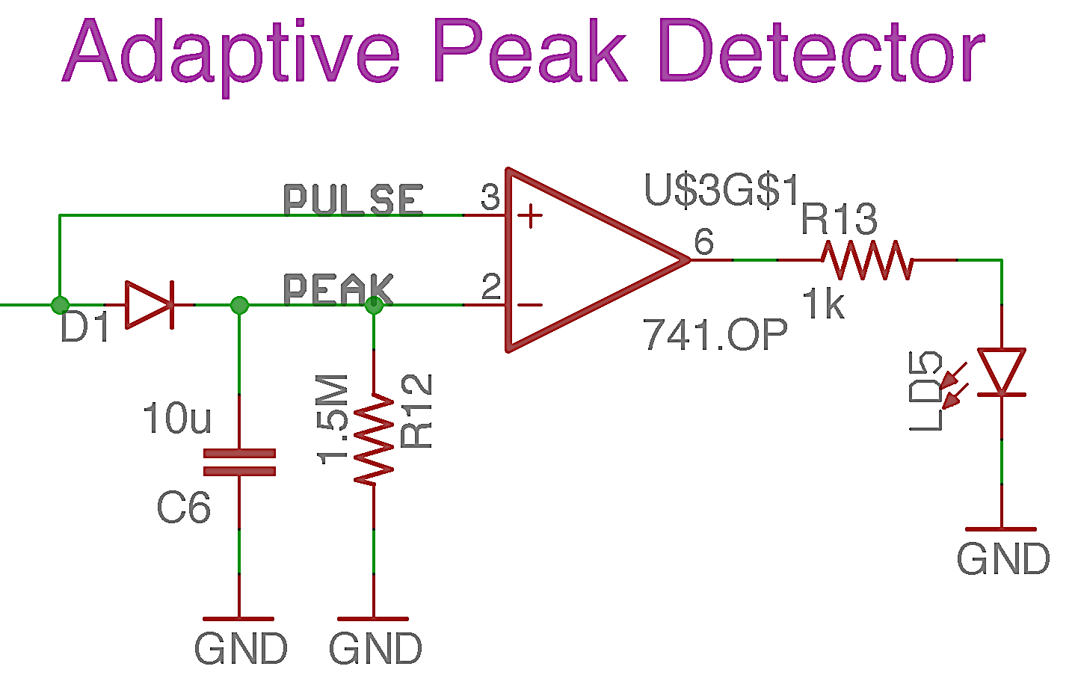

*Figure 6: Peak detector and comparator circuit. The peak detector auto-adjusts a threshold or the pulse output and the comparator lights up an LED when a heartbeat comes through.*

***Adaptive Peak Detector Circuit***

As you noticed in Figure 1, our pulse waveform has a very predominant peak, which corresponds to the systolic phase of our cardiac cycle. We will attempt to create a circuit that will automatically detect this peak and will blink an LED in response. The height of the pulse waveform’s predominant peak varies with a number of different factors. We would like our circuit to automatically adapt to these changes without additional intervention from the user. We will accomplish this with an adaptive peak detector.

A peak detector circuit, as the name suggests, finds the peak voltage of the input signal. It accomplishes this primarily with the diode and capacitor. A capacitor stores charge. If we were to connect a capacitor to a 9V battery, then remove the 9V battery, the voltage across the capacitor would remain 9V even with the battery removed. The peak detector utilizes this ability of the capacitor to measure the peak output voltage of our photoplethysmography circuit.

A diode only allows the flow of current in one direction (the direction the arrow is pointing). This prevents the capacitor from discharging. Essentially, this would mean that the capacitor would hold the 9V charge indefinitely. We do not want the capacitor to hold charge indefinitely, so we place a resistor in parallel with the capacitor. The resistor discharges the capacitor at a rate equal to the RC time constant (τ) of the resistor-capacitor circuit where,

$τ=R*C$ (4)

We set our RC time constant so that the capacitor holds the charge long enough to set a relatively level threshold with only small change in voltage before our next pulse. With the RC circuit, we create an adaptive peak detector that can adjust its level based on the peak voltage of the pulse waveform.

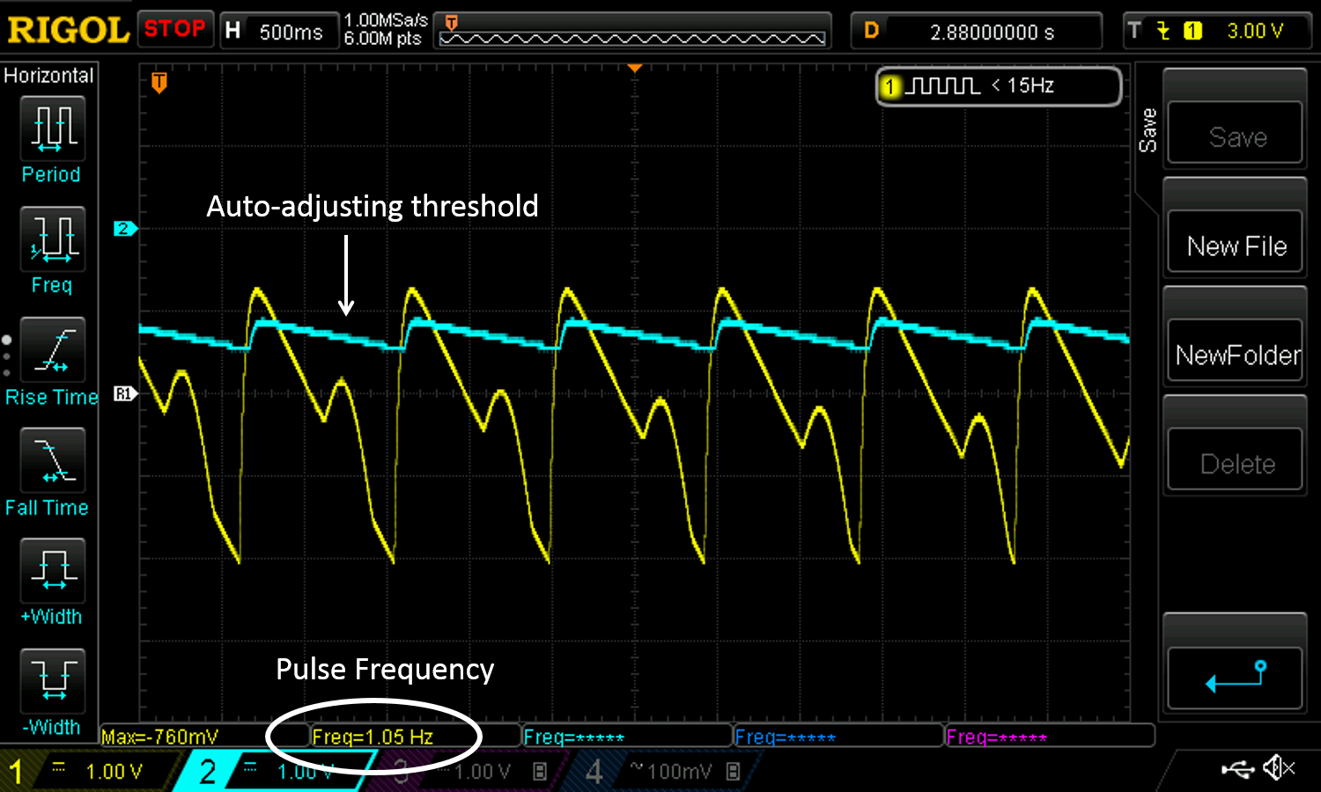

*Figure 7: Example output of PulseFit highlighting the action of the adaptive peak detector in relation to the pulse waveform. Notice the pulse waveform is momentarily higher than the peak detector during the systolic phase. (Ignore the exact output voltages as this graph was obtained from a different circuit)*

***Comparator and LED indicator***

A comparator compares the voltage between an op amp’s two inputs (inverting and non-inverting). The output of the comparator is determined by the following equation

$V_{out}=A_{OL}\left(V_{IN+}-V_{IN-}\right), with V^{-}≤Vout ≤V^{+}$ (5)

Where AOL is the open loop gain of the amplifier, which we will assume to be infinity, VIN+ is the voltage at the non-inverting pin, and VIN- is the voltage at the inverting pin. Do not confuse V+ and V-, which are the supply voltages of the op amp and VIN+ and VIN-, which are the voltages at the non-inverting and inverting input respectively. In short, if the voltage at VIN+ is higher than VIN-, the output of the amplifier will hit the positive rail (V+). If the voltage at VIN- is higher than VIN+, the output of the amplifier will hit the negative rail (V-).

We connected the pulse output to the non-inverting pin of the comparator and the peak detector to the inverting pin. If the pulse output voltage exceeds the voltage of the peak detector, the output of the comparator is positive, which lights our LEDs indicating a heartbeat (systole). If the pulse output does not exceed the voltage of the peak detector, the LEDs will not light.

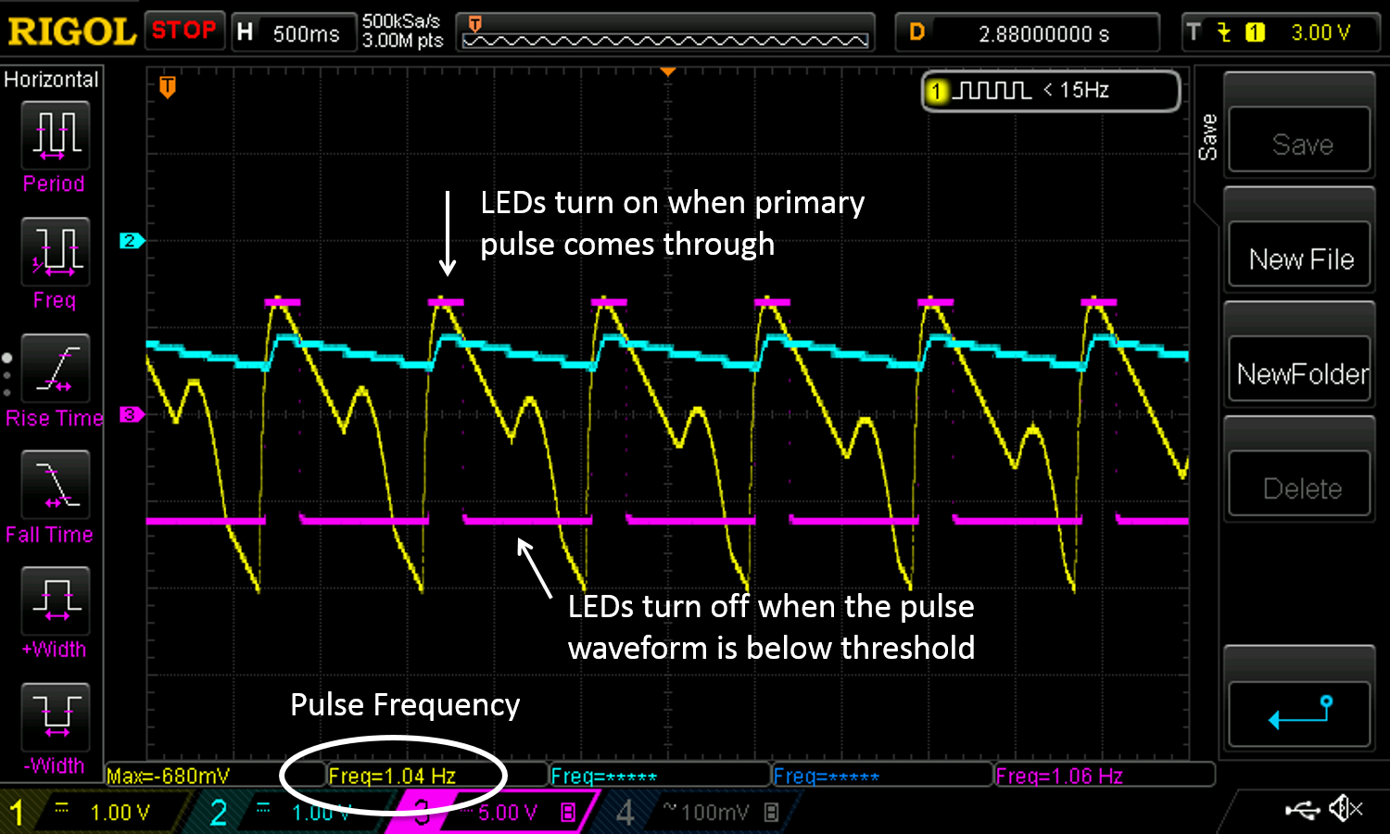

*Figure 8: Example output of PulseFit highlighting the action of the adaptive peak detector in relation to the pulse waveform. Also showing the comparator output. Notice the comparator output voltage when the pulse waveform voltage is higher than the peak detector voltage. (Ignore the exact output voltages as this graph was obtained from a different circuit)*

***Testing***

1. Power the op amps with +/- 12 V from the benchtop power supply
2. Output a 1 Hz, 10 Vpp sine waveform from the function generator and place it at the inputs labeled “PULSE” and “PEAK.” The LED should pulse momentarily every one second.
3. View the sine wave, peak detector output, and comparator output on the oscilloscope. You should see outputs similar to Figure x

***Try It!***

1. After you’ve had a little fun viewing the LED turning on and off, decrease the function generator output to 7 Vpp. You should see the peak detector output voltage adjust to the change in pulse voltage and continue toggling the LED on and off after settling a bit.

**Part #5: Heart-shaped LED Indicator**

If you feel so inclined, feel free to make the heart-shaped LED indicator as pictured below. Be sure to wire all the LEDs in parallel ☺.

1. Arrange all the LED in the perfboard such that it makes the desired shape
2. Solder all the anodes (the longer leg) of the LEDs together.
3. Solder all the cathodes (the shorter leg) of the LEDs together.
4. I used about 22 LEDs in the pictured example

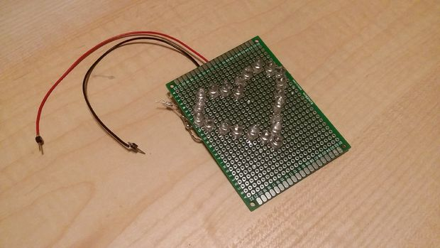

*Figure 9: Heart-shaped LED design placed at the output of the comparator. The LEDs light up when a heartbeat is detected. All the LEDs are wired in parallel.*

**Revision History**

|  |  |  |
| --- | --- | --- |
| **Revision Code** | **Revision**  **Date** | **Description** |
| A | x/xx/2017 | * Initial document for first year of #FunTimesWithTheTA |
| B | 9/28/2017 | * Include new circuit design utilizing LM741 instead of MCP6002. * Also added additional information to introduction to discuss the use of transimpedance vs. reflectance photoplethysmography * Added oscilloscope outputs to show example peak detector and comparator performance. * Added section to include heart-shaped LED indicator * Added a bit of information to testing sections and also a few “NOTEs” * Added #FunTimesWithTheTA logo to page as well as page numbers and footers |
| B | 10/11/2018 | * Added ABET Outcomes, updated Learning Objectives, sharpened the images, and added link to the CircuitLab simulation. |